# 1.reactjs-HOL-solutions

Created a App called myfirstreactapp , using command prompt:

Using these commands:

>npm install -g create-react-app

>npx create-react-app myfirstreactapp

>cd myfirstreactapp

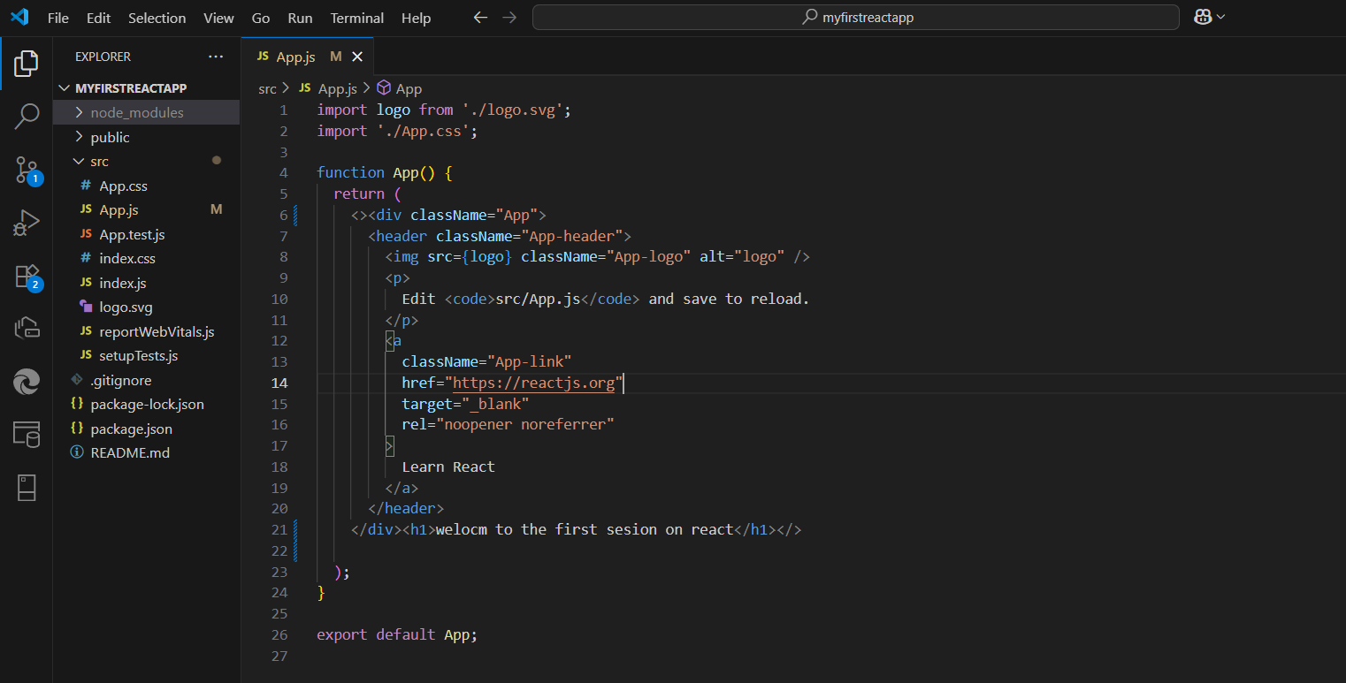

Then by using > npm start

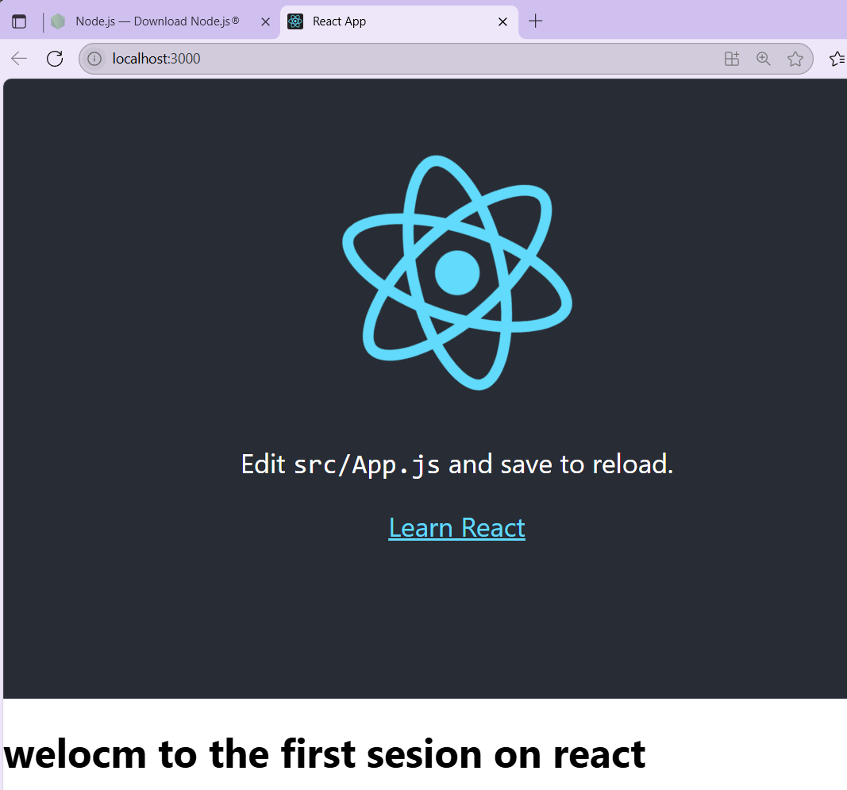

And started the application on localhost:3000.